# **Department of Computer Science and Engineering Islamic University of Technology (IUT)** A subsidiary organ of OIC

# 

# **Laboratory Report**

# CSE 4412 : Data Communication and Networking Lab

## Lab 3

## **Name: Abir Hossain Student ID: 190042139 Section: SWE (Lab B) Semester: 4th Academic Year: 2021**

**Date of Submission: 09-12-21**

### **Title:** Creating a Simple LAN (Local Area Network) in CISCO Packet Tracer.

### **Objective**:

1. Create a Simple LAN (Ring Topology) by connecting multiple end devices
2. Significance of IP address
3. Difference between Switch and Hub.

### **Devices/ software Used**:

1. Cisco Packet Tracer.

### **Diagram of the experiment:**

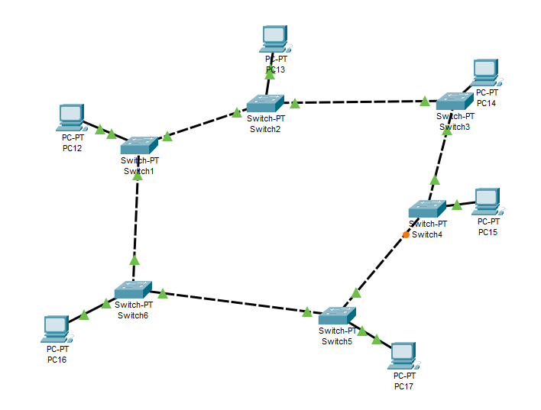

### **Working Procedure:**

**1) Create a Simple LAN (Ring Topology) by connecting multiple end devices**

1. I created a few end devices( generic pc in this case).
2. Then I created a router for each of end devices.
3. Connected one router with one pc.
4. Connected every router with its nearby two routers and hence completed the ring.
5. Then I pinged two devices which are not directly connected to check if the ring is working.
6. Deleted one cable to see if the ring is still working.

**2) Significance of IP address:**

1. IP addresses are the identifier that allows information to be sent between devices on a network
2. IP addresses are used to connect devices to the internet.
3. A packet on the internet knows it’s destination by the IP address.
4. During a packet transfer the IP address never changes.
5. But due to shortage of IP addresses and an abundance of devices to connect to the internet, we use a system called subnetting to share one single IP address with many people.
6. So, a single IP address can occur in many different networks. I.e: You can have the same IP address as someone in a different country.’
7. Your device can have different IP addresses based on the network it is connected to.
8. Same IP address can occur in devices connected to different networks.

**3) Difference between Switch and Hub**

Hub:

1. Hub is operated on the physical layer.
2. Transmission mode is half-duplex.
3. Singular domain of collision is present in a hub.
4. Uses electrical signal orbits.
5. A network hub can’t store MAC(Multiple Access Control) addresses.
6. Hub cannot be used as a repeater.
7. In hub., packet filtering is not provided.

Router:

1. Switch is operated on the data link layer.
2. Transmission mode is full duplex.
3. Varied ports have different collision domains.
4. Uses frame & packets.
5. Switch can store MAC addresses and can filter packets.
6. Switch can be used as a repeater.
7. Packet filtering is available.

In hub, packets are sent to all connected devices, while switch filters packets and sends them to only certain devices.

### **Observation**:

1. Saw that the ring topology is working when it should and not working when it shouldn’t.
2. Ring topology works when the ring is complete.
3. It doesn’t work when the ring is broken.
4. Can have different IP addresses when they are not in the same network (but indirectly connected).
5. Hub sends packet to every connected device.
6. Switch sends packet to only devices which should receive the packet.

### **Challenges:**

1. Signing into cisco is very problematic.
2. Properly configuring IP addresses was very important.
3. Knowing which port and cable to connect to the devices was difficult at first.

### 